

A
Project Report
on

CareerMatch
submitted as partial fulfillment for the award of

BACHELOR OF TECHNOLOGY
DEGREE
SESSION 2025-26
in

C.S.E.(AI&ML)
By
Anand Sharma (2300291539002)
Jyoti (2300291539006)
Harsh Vikram Singh (2300291539005) Prabal Gupta (2300291539008)

Under the supervision of
Payal Chhabra
KIET Group of Institutions, Ghaziabad
Affiliated to
Dr. A.P.J. Abdul Kalam Technical University, Lucknow

(Formerly UPTU)
March, 2026

DECLARATION

We hereby declare that this submission is our own work and that, to the best of our knowledge and belief, it contains no material previously published or written by another person nor material which to a substantial extent has been accepted for the award of any other degree or diploma of the university or other institute of higher learning, except where due acknowledgment has been made in the text.

Anand Sharma (2300291539002)

Jyoti (2300291539006)

Harsh Vikram Singh (2300291539005) Prabal Gupta (2300291539008)
Date:

CERTIFICATE

This is to certify that Project Report entitled “Project Title” which is submitted by Student name in partial fulfillment of the requirement for the award of degree B. Tech. in Department of CSE (AIML) of Dr. A.P.J. Abdul Kalam Technical University, Lucknow is a record of the candidates own work carried out by them under my supervision. The matter embodied in this report is original and has not been submitted for the award of any other degree.

Supervisor Name Dr. Rekha Kashyap

(Designation) Dean – CSE (AI/AI&ML)

Date:

ACKNOWLEDGEMENT

It gives us a great sense of pleasure to present the report of the B. Tech Project undertaken during B. Tech. Final Year. We owe special debt of gratitude to superisor name, Department of CSE(AIML), KIET, Ghaziabad, for his constant support and guidance throughout the course of our work. His sincerity, thoroughness and perseverance have been a constant source of inspiration for us. It is only his cognizant efforts that our endeavors have seen light of the day.
We also take the opportunity to acknowledge the contribution of Dr. Rekha Kashyap, Dean of the Department of Computer Science & Engineering (AI/AI&ML), KIET, Ghaziabad, for his full support and assistance during the development of the project. We also do not like to miss the opportunity to acknowledge the contribution of all the faculty members of the department for their kind assistance and cooperation during the development of our project.
We also do not like to miss the opportunity to acknowledge the contribution of all faculty members, especially faculty/industry person/any person, of the department for their kind assistance and cooperation during the development of our project. Last but not the least, we acknowledge our friends for their contribution in the completion of the project.

Date:
Anand Sharma (2300291539002)
Jyoti (2300291539006)
Harsh Vikram Singh (2300291539005) Prabal Gupta (2300291539008)

ABSTRACT
The transition from academic life to professional employment is often challenging for fresh graduates due to the difficulty of identifying job opportunities that match their skills and qualifications. Many existing job portals require candidates to manually search for jobs, which may lead to irrelevant results and inefficient use of time. This problem highlights the need for intelligent systems that can automatically analyze candidate profiles and recommend suitable job opportunities.

The CareerMatch project presents a smart web-based platform designed to assist fresh graduates in discovering appropriate job roles based on their skills, educational background, and career interests. The system allows users to upload their resumes, which are then analyzed using text processing techniques to extract important information such as technical skills, qualifications, and keywords.

The extracted information is processed using machine learning techniques such as Term Frequency–Inverse Document Frequency (TF-IDF) for text feature extraction and classification algorithms to compare candidate profiles with available job descriptions. Based on this analysis, the system recommends job roles that closely match the user’s profile.

The application is implemented as a web platform using HTML, CSS, and JavaScript for the user interface, PHP for backend processing, and MySQL for database management. The system also includes features such as user registration, resume upload, skill analysis, and personalized job recommendations.

The primary goal of CareerMatch is to simplify the job search process for fresh graduates by providing relevant and personalized job suggestions. By integrating machine learning with web technologies, the platform improves the efficiency of job matching and helps candidates identify suitable employment opportunities more effectively.

TABLE OF CONTENTS Page No.

DECLARATION…………………………………………………………………… i CERTIFICATE...…………………………………………………………………… ii
ACKNOWLEDGEMENT ..………………………………………………………… iii
ABSTRACT………………………………………………………………………... iv
LIST OF FIGURES.………………………………………………………………... vii
LIST OF TABLE ....………………………………………………………………… viii
LIST OF ABBREVIATIONS………………………………………………………. ix
CHAPTER 1 (INTRODUCTION)……..…………………………………………… 1
  - Introduction………………………………...……………………………………. 1
  - Project Description………………………………………………………………. 2
CHAPTER 2 (LITERATURE OVERVIEW)………………………………………. 3
  - Overview of Job Recommendation Systems ………………………………........ 3
  - Resume Parsing Techniques …………………………………............................. 3
  - Machine Learning Techniques in Recruitment…………………………………. 4
  - Existing Online Job Portals ................................................................................... 4
  - Summary ............................................................………………………………… 5

CHAPTER 3 (PROPOSED TECHNOLOGY) ……………………………………… 6
  - System Overview ................................................................................................... 6
  - System Architecture ............................................................................................... 6
  - Resume Processing and Skill Extraction ............................................................... 8
  - Job Matching Using TF-IDF ................................................................................. 8
  - System Modules .................................................................................................... 9
  - Workflow of the Proposed System ....................................................................... 10
CHAPTER 4 (RESULTS AND DISCUSSION) ……………………………………. 13
  - System Implementation ......................................................................................... 13
  - Functional Results ................................................................................................. 13
  - Sample Output ....................................................................................................... 14
  - Discussion ............................................................................................................. 15

CHAPTER 5(CONCLUSION AND FUTURE SCOPE) 16
  - Conclusion 16
  - Future Scope 16
REFERENCES 18
APPENDIX 1 19
RESEARCH PAPER / PATENT 22
PROOF OF SUBMISSION / ACCEPTANCE / PUBLICATION ………………………. 23
PLAGIARISM REPORT 24

LIST OF FIGURES

Figure No | Description | Page No
Figure 3.1 | System Architecture of CareerMatch | 07
Figure 3.2 | Workflow of CareerMatch System | 11
Figure 3.3 | Data Flow Diagram | 11
Figure 3.4 | Entity Relationship Diagram | 12

LIST OF TABLES

Table No. | Description | Page No.
Table 3.1 | Technology Stack Used | 07
Table 3.2 | System Modules | 09
Table 4.1 | Resume Skill Extraction | 11
Table 4.2 | Job Recommendation Results | 12
Table A.1 | Users Table | 16
Table A.2 | Resumes Table | 16
Table A.3 | Jobs Table | 16

LIST OF ABBREVIATIONS

Abbreviation | Full Form
AI | Artificial Intelligence
API | Application Programming Interface
CSS | Cascading Style Sheets
DFD | Data Flow Diagram
DBMS | Database Management System
ER | Entity Relationship
HTML | HyperText Markup Language
IT | Information Technology
ML | Machine Learning
MySQL | My Structured Query Language
NLP | Natural Language Processing
PHP | Hypertext Preprocessor
TF-IDF | Term Frequency – Inverse Document Frequency
UI | User Interface
UX | User Experience

CHAPTER 1 INTRODUCTION

INTRODUCTION
The rapid growth of technology and the increasing number of graduates entering the workforce have made the job search process more competitive and complex. Fresh graduates often face difficulties in finding suitable employment opportunities because they lack experience and may not clearly understand which job roles best match their skill sets. Traditional job search methods require candidates to manually explore multiple job portals and analyze numerous job postings, which can be time-consuming and inefficient.

Modern recruitment systems are gradually adopting intelligent technologies to improve the job matching process. Techniques such as data analysis, machine learning, and natural language processing (NLP) enable automated evaluation of candidate profiles and job descriptions. These technologies help identify patterns and similarities between candidate skills and employer requirements, allowing systems to recommend suitable job opportunities.

Recommendation systems have already proven successful in various domains such as e- commerce, entertainment platforms, and social media. Applying similar concepts to the recruitment domain can significantly improve the efficiency of job matching. By analyzing user profiles, skills, and job requirements, recommendation systems can provide personalized job suggestions that align with the candidate’s capabilities and interests.

The platform is developed using modern web technologies including HTML, CSS, JavaScript, PHP, and MySQL, along with machine learning methods such as TF-IDF for textual analysis. By automating the job matching process, CareerMatch reduces manual effort and improves the likelihood of candidates finding relevant job opportunities.

PROJECT DESCRIPTION
CareerMatch – Smart Job Recommendation Platform for Fresh Graduates is a web-based application designed to connect job seekers with suitable employment opportunities based on their skills and academic background. The system focuses on simplifying the job search process by providing automated job recommendations through resume analysis.
The platform allows users to create an account, upload their resumes, and view recommended job roles generated by the system. Once the resume is uploaded, the system processes the document to extract key information such as technical skills, tools, programming languages, and educational details. This information is then converted into structured data that can be analyzed by the recommendation engine.
The recommendation engine compares the extracted resume information with job descriptions available in the database. Text analysis techniques are applied to determine the similarity between candidate profiles and job requirements. Based on this comparison, the system generates a list of job opportunities that closely match the candidate’s skill set.
The system architecture consists of several modules, including user authentication, resume management, job data management, recommendation processing, and an administrative module. The administrative section allows administrators to add, update, and manage job listings in the database.
The CareerMatch platform is implemented using a full-stack web development approach, where the frontend provides an interactive interface for users and the backend handles data processing and database operations. The database stores user details, resumes, extracted skills, and job listings, enabling efficient retrieval and analysis of information.
The main objective of this project is to bridge the gap between fresh graduates and potential employers by providing a system that intelligently recommends job opportunities. By automating resume analysis and job matching, the platform improves the efficiency of job searching and helps candidates discover career opportunities that align with their abilities and interests.

CHAPTER 2 LITERATURE REVIEW

Overview of Job Recommendation Systems
The rapid expansion of online recruitment platforms has transformed the way employers and job seekers connect. Traditional recruitment processes required candidates to search for job opportunities manually through newspapers, employment agencies, or company websites. With the advancement of the internet and digital platforms, job portals have become one of the most common ways for individuals to find employment opportunities.

A job recommendation system is a software-based solution that assists job seekers in identifying suitable job opportunities based on their profile information. These systems analyze candidate data such as educational background, technical skills, experience, and interests to recommend job roles that best match their qualifications. The main objective of such systems is to simplify the recruitment process by reducing the time required for job searching and increasing the accuracy of job matching.

Many modern job portals use recommendation techniques to improve user experience. These systems collect and analyze user data to provide personalized job suggestions. The effectiveness of these systems depends on how accurately the platform can analyze both the candidate’s profile and the job requirements.

The CareerMatch platform is developed with the goal of improving the job recommendation process for fresh graduates. By integrating resume analysis and intelligent matching techniques, the system aims to provide more relevant job suggestions compared to traditional search-based job portals.

Resume Parsing Techniques
Resume parsing is a key technology used in automated recruitment systems. It refers to the process of extracting structured information from resumes that are usually written in unstructured formats such as PDF or Word documents. Recruiters often receive a large number of resumes for a single job position, which makes manual analysis inefficient and time-consuming.

Automated resume parsing tools use text processing techniques to identify and extract important details from resumes. These details may include the candidate’s name, contact information, educational qualifications, work experience, certifications, and technical skills. Once the information is extracted, it can be organized into a structured format that can be easily analyzed by computer systems.

Natural Language Processing (NLP) techniques are commonly used for resume parsing. NLP allows the system to understand and interpret human language by analyzing keywords and sentence structures within the document. Through keyword identification and text analysis, the system can determine the relevant skills and competencies mentioned in the resume.

In the CareerMatch system, resume parsing plays an essential role in extracting the skills of candidates. These extracted skills are later used by the recommendation engine to compare the candidate profile with available job descriptions.

Machine Learning Techniques in Recruitment Systems
Machine learning has significantly improved the performance of modern recommendation systems. In recruitment platforms, machine learning algorithms help analyze large volumes of textual data from resumes and job descriptions. These algorithms can identify patterns and relationships between candidate skills and job requirements.

One widely used technique for text analysis is Term Frequency–Inverse Document Frequency (TF-IDF). This method measures the importance of words in a document relative to a collection of documents. In job recommendation systems, TF-IDF helps identify important keywords from resumes and job descriptions, enabling the system to measure similarity between them.

Another commonly used method is classification algorithms such as Support Vector Machines (SVM) and its variations. These algorithms can categorize resumes into different job roles based on the extracted features. By training the system with job description data, the algorithm can learn which types of skills are associated with particular job positions.

Machine learning techniques enable recruitment systems to automate the job matching process and improve recommendation accuracy. These approaches reduce manual effort while increasing the relevance of suggested job opportunities.

Existing Online Job Portals
Several online platforms currently provide job search and recruitment services. Websites such as LinkedIn, Indeed, and Naukri allow job seekers to create profiles, upload resumes, and apply for job positions. These platforms have simplified the recruitment process by enabling direct interaction between employers and candidates.

Although these platforms offer useful features, they still face certain limitations. Many job portals rely on keyword-based search systems where users must manually filter job listings. As a result, users may encounter a large number of irrelevant job suggestions that do not match their skill sets.

Another challenge is that fresh graduates often lack work experience, which makes it difficult for traditional systems to recommend suitable job opportunities. Most existing platforms prioritize experienced candidates, leaving limited guidance for new graduates entering the job market.

The CareerMatch project attempts to address these issues by focusing specifically on fresh graduates. By analyzing the skills mentioned in resumes rather than relying solely on manual search filters, the system can generate more accurate job recommendations.

Summary
The literature review highlights the importance of intelligent job recommendation systems in modern recruitment processes. Technologies such as resume parsing, natural language processing, and machine learning have significantly improved the efficiency of candidate evaluation and job matching.

While existing job portals provide basic recommendation features, they often rely on manual search and keyword filtering methods. These approaches may not always deliver personalized results, particularly for fresh graduates with limited work experience.

The CareerMatch system builds upon these existing technologies by integrating resume analysis with machine learning techniques. This approach aims to provide more accurate and personalized job recommendations, thereby improving the overall job search experience for fresh graduates.

CHAPTER 3 PROPOSED METHODOLOGY

System Overview
The proposed system, CareerMatch, is designed as an intelligent job recommendation platform that assists fresh graduates in identifying job opportunities that match their skills and qualifications. The system analyzes the user’s resume and compares the extracted information with job descriptions stored in the database to generate personalized job recommendations.

The platform operates as a web-based application where users can create accounts, upload resumes, and receive job suggestions based on their profile. The system combines web development technologies with text analysis techniques to automate the process of job matching.

The main idea behind the proposed methodology is to extract meaningful information from resumes, analyze the extracted data, and compare it with job requirements using machine learning techniques. By implementing this approach, the system reduces manual effort in searching for jobs and improves the accuracy of recommendations.

System Architecture
The CareerMatch platform follows a three-tier architecture, which consists of the presentation layer, application layer, and data layer. This architecture ensures efficient communication between the user interface, processing logic, and database.

Presentation Layer (Frontend)
This layer provides the graphical user interface through which users interact with the system. It is developed using HTML, CSS, and JavaScript, which allow users to register, log in, upload resumes, and view recommended job opportunities.

Application Layer (Backend)
The backend is responsible for handling application logic and processing user requests. It is implemented using PHP, which processes resume uploads, manages user authentication, and communicates with the machine learning module for job matching.

Data Layer (Database)
The data layer stores all relevant information such as user profiles, resumes, extracted skills, and job listings. A MySQL database is used to manage and organize this data efficiently.

The interaction between these layers enables the system to process user input, perform resume analysis, and provide job recommendations in an efficient manner.

Figure 3.1 – System Architecture Diagram

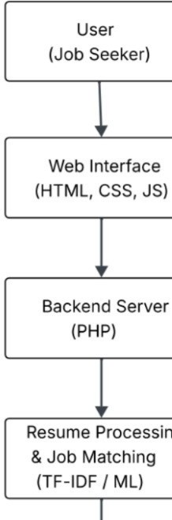
Table 3.1: Technology Stack Used in the System

Component | Technology Used | Purpose
Frontend | HTML, CSS, JavaScript | To design the user interface of the platform
Backend | PHP | To handle server-side processing
Database | MySQL | To store user data and job listings
Machine Learning | Python | For resume analysis and job matching
NLP Library | NLTK | For text preprocessing and skill extraction

Resume Processing and Skill Extraction
One of the core components of the proposed system is resume processing. When a user uploads a resume, the system reads the document and extracts useful textual information. Resumes often contain unstructured data, so text processing techniques are used to identify meaningful keywords and phrases.

The system first converts the resume into a text format that can be processed by the algorithm. After conversion, unnecessary characters and irrelevant words are removed during preprocessing. This step helps improve the quality of the data used for analysis.

Following preprocessing, the system identifies important skills mentioned in the resume. These skills may include programming languages, software tools, frameworks, and technical competencies. The extracted skills are then stored in the database and used as input for the job recommendation process.

This automated extraction process eliminates the need for manual resume evaluation and allows the system to analyze candidate profiles more efficiently.

Job Matching Using TF-IDF
To identify the most relevant job opportunities for a candidate, the system applies text similarity techniques. One of the methods used in the CareerMatch system is Term Frequency–Inverse Document Frequency (TF-IDF).

TF-IDF is a statistical technique used to measure the importance of a word in a document relative to a collection of documents. In the context of job recommendation, it helps determine how relevant certain keywords are within resumes and job descriptions.

The process works as follows:

    - The system converts both resumes and job descriptions into text vectors using the TF- IDF method.
    - Important keywords are assigned higher weights depending on their frequency and uniqueness.
    - The similarity between the candidate profile and job descriptions is calculated using these weighted vectors.
    - Jobs with the highest similarity scores are recommended to the user.

System Modules
The CareerMatch platform consists of several functional modules that work together to provide job recommendations.

User Registration and Login Module
This module allows users to create accounts and securely log into the system. Authentication ensures that only authorized users can access their profiles and job recommendations.

Resume Upload Module
Users can upload their resumes in supported formats such as PDF or Word documents. The uploaded resume is then processed by the system to extract relevant information.

Resume Analysis Module
This module performs text preprocessing and skill extraction from the uploaded resume. The extracted information is stored in the database for further analysis.

Job Recommendation Module
The recommendation engine compares extracted resume data with job descriptions using the TF- IDF technique. Based on similarity scores, the system suggests suitable job roles to the user.

Admin Module
The administrative module allows administrators to manage job listings, update job descriptions, and maintain the database. This ensures that the system always contains updated job opportunities.

Table 3.2: System Modules Description

Module Name | Description
User Registration Module | Allows new users to create an account on the platform
Login Module | Authenticates users and allows secure access
Resume Upload Module | Enables users to upload resumes for analysis
Resume Analysis Module | Extracts skills and important information from resumes
Job Recommendation Module | Suggests relevant job roles based on extracted skills
Admin Module | Allows administrators to manage job listings

Workflow of the Proposed System
The overall workflow of the CareerMatch platform can be summarized as follows:

    - The user registers and logs into the system.
    - The user uploads their resume through the platform.
    - The system processes the resume and extracts relevant skills and keywords.
    - The extracted information is analyzed using text processing and machine learning techniques.
    - The system compares the candidate profile with available job descriptions.
    - The platform generates a list of job recommendations that match the candidate’s skill set.

This workflow ensures that users receive job suggestions that are relevant to their qualifications and interests.

Figure 3.2 – System Workflow Diagram

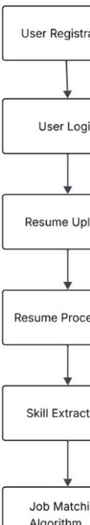
Figure 3.3 – Data Flow Diagram (DFD Level 0)

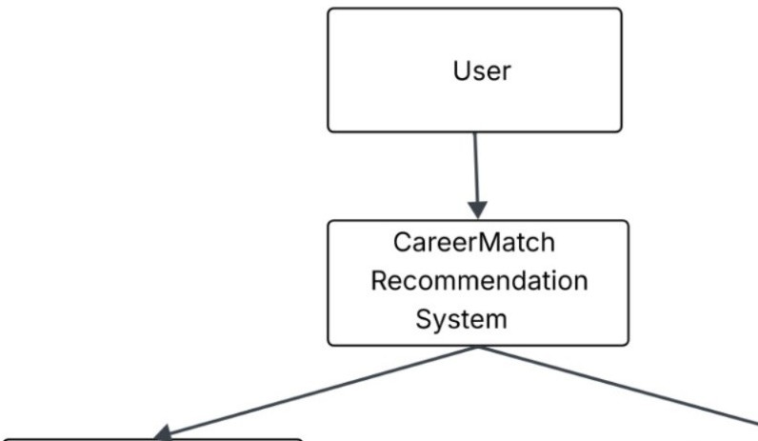

Figure 3.4 – Entity Relationship Diagram (ER Diagram)

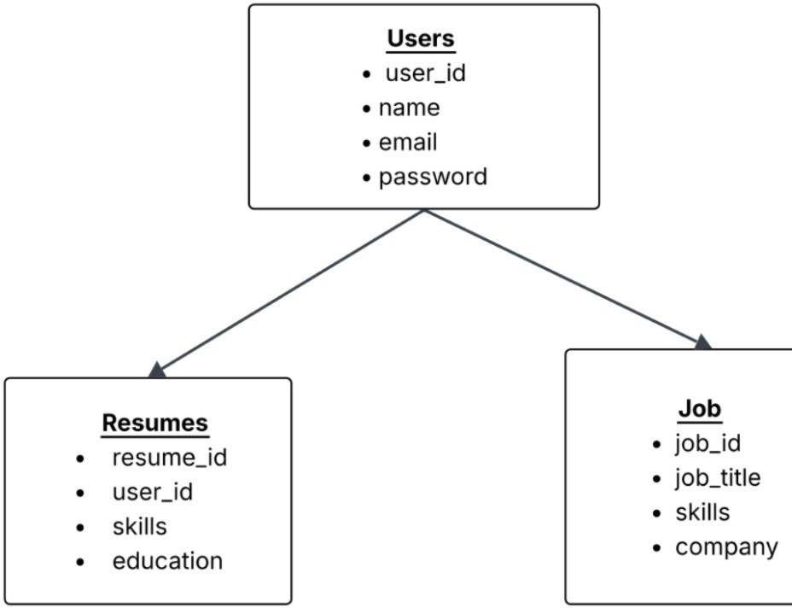

CHAPTER 4 RESULTS AND DISCUSSION

System Implementation
The CareerMatch system was implemented as a web-based application designed to assist fresh graduates in identifying relevant job opportunities based on their skills and qualifications. The system integrates frontend technologies such as HTML, CSS, and JavaScript to provide an interactive user interface, while PHP is used for server-side processing. The system stores user data and job listings in a MySQL database, which ensures efficient storage and retrieval of information.

The implementation of the system focuses on simplifying the job search process by automating resume analysis and job matching. Users can register on the platform, upload their resumes, and receive personalized job recommendations based on the extracted skills. The platform processes the uploaded resumes and compares them with job descriptions stored in the database to determine suitable matches.

The development of the CareerMatch system demonstrates how web technologies and machine learning techniques can be combined to create an efficient job recommendation platform.

Functional Results
The developed system was tested using different user profiles and resumes to evaluate its functionality. The testing process involved uploading multiple resumes containing various technical skills and analyzing the job recommendations generated by the system.

The following functionalities were successfully implemented:

User Registration and Login
Users are able to create accounts and securely log into the system using authentication mechanisms.

Resume Upload and Processing
The platform allows users to upload their resumes in supported formats. Once uploaded, the system processes the document and extracts relevant keywords and skills.

Skill Extraction
Important technical skills mentioned in the resume are identified and stored in the database for further analysis.

Table 4.1: Sample Resume Skill Extraction

Resume ID | Extracted Skills | Education
R001 | Python, Machine Learning, SQL | B.Tech Computer Science
R002 | Java, Spring Boot, MySQL | B.Tech Information Technology
R003 | HTML, CSS, JavaScript, React | B.Tech Computer Science

Job Recommendation Generation
The recommendation engine compares the extracted skills with job descriptions and generates a list of relevant job opportunities.

Job Listing Management
The administrator can add and manage job postings within the system database.

These functionalities confirm that the system successfully performs automated job matching based on candidate profiles.

Sample Output
When a user uploads a resume, the system performs text analysis to extract skills and match them with available job descriptions. For example, if a candidate’s resume contains skills such as Python, Machine Learning, and Data Analysis, the system identifies these keywords and compares them with job requirements.

Based on the similarity between the candidate’s profile and job descriptions, the system generates a list of recommended job roles. These recommendations may include positions such as:

- Data Analyst
- Machine Learning Engineer
- Software Developer
- Backend Developer

The results are displayed on the user dashboard, allowing candidates to explore job opportunities that match their skills.

Table 4.2: Job Recommendation Results

Candidate ID | Key Skills | Recommended Job Role
C101 | Python, Data Analysis | Data Analyst
C102 | Java, Backend Development | Backend Developer
C103 | HTML, CSS, JavaScript | Frontend Developer

Discussion
The results obtained from the implementation demonstrate that the CareerMatch platform effectively assists users in discovering job opportunities that align with their skill sets. By automating resume analysis and job matching, the system reduces the time required for manual job searches.

The use of text analysis techniques such as TF-IDF improves the accuracy of matching resumes with job descriptions. This approach enables the system to identify relevant job opportunities even when the wording in resumes and job descriptions differs slightly.

Another advantage of the system is its user-friendly interface, which allows users to easily upload resumes and view recommended job roles. The modular design of the platform also makes it easier to update job listings and maintain the database.

However, certain limitations exist in the current implementation. The accuracy of recommendations depends on the quality of job data stored in the system and the completeness of the information provided in the user’s resume. Expanding the dataset and integrating real-time job APIs could further improve the performance of the system.

Overall, the results indicate that the CareerMatch system successfully demonstrates the feasibility of an intelligent job recommendation platform for fresh graduates.

CHAPTER 5 CONCLUSION AND FUTURE SCOPE

Conclusion
The CareerMatch project presents a web-based job recommendation platform designed to assist fresh graduates in identifying suitable job opportunities based on their skills, educational background, and career interests. In the current job market, many graduates face challenges while searching for relevant employment opportunities due to the large number of job listings and the lack of personalized guidance. The CareerMatch system addresses this issue by providing an intelligent platform that analyzes user resumes and recommends job roles that closely match the candidate’s profile.

The system integrates web development technologies and text analysis techniques to automate the job matching process. By allowing users to upload their resumes, the platform can extract important skills and compare them with job descriptions stored in the database. The use of techniques such as TF-IDF for text processing enables the system to identify relevant keywords and measure the similarity between candidate profiles and job requirements.

The implementation of the system demonstrates that an automated job recommendation platform can significantly simplify the job search process. The developed application provides a user- friendly interface, efficient resume processing, and personalized job suggestions. The modular structure of the system also allows easy management of job listings and user data.

Overall, the CareerMatch platform helps bridge the gap between fresh graduates and potential employers by providing relevant job recommendations based on candidate skills. The project highlights how machine learning and web technologies can be effectively combined to create intelligent recruitment support systems.

Future Scope
Although the current version of the CareerMatch platform successfully performs resume analysis and job recommendation, there are several opportunities for further improvement and expansion.

One possible enhancement is the integration of real-time job APIs from major job portals. This would allow the system to automatically retrieve updated job listings from external platforms and provide users with a larger number of opportunities.

Another improvement could involve implementing advanced machine learning or deep learning models to enhance the accuracy of job recommendations. More sophisticated

algorithms could analyze candidate profiles in greater detail and identify complex relationships between skills and job requirements.

The system could also be extended to include career guidance features, such as skill gap analysis and course recommendations. This would help users identify the skills they need to develop in order to qualify for specific job roles.

In addition, developing a mobile application version of CareerMatch would make the platform more accessible to users who prefer using smartphones for job searching. Mobile integration could also enable features such as push notifications for new job recommendations.

Future versions of the system could also incorporate interview preparation tools, company insights, and networking features to further assist job seekers in their career development.

With these improvements, the CareerMatch platform has the potential to evolve into a comprehensive career support system that not only recommends jobs but also helps users build the skills required for successful employment.

REFERENCES

- Python Software Foundation, “Python Documentation,” Available: https://www.python.org

- Natural Language Toolkit (NLTK), “NLTK Documentation,” Available: https://www.nltk.org

- Oracle Corporation, “MySQL 8.0 Reference Manual,” Available: https://dev.mysql.com/doc/

- Mozilla Developer Network (MDN), “Web Development Technologies,” Available: https://developer.mozilla.org

APPENDIX 1

Database Schema
The CareerMatch platform uses a MySQL database to store user information, resumes, extracted skills, and job listings. The following tables are used in the system.

Table A.1 Users Table

Field Name | Data Type | Description
user_id | INT (Primary Key) | Unique ID of the user
name | VARCHAR(100) | Name of the user
email | VARCHAR(100) | Email address
password | VARCHAR(255) | Encrypted password
created_at | DATETIME | Account creation time

Table A.2 Resumes Table

Field Name | Data Type | Description
resume_id | INT (Primary Key) | Unique ID for resume
user_id | INT (Foreign Key) | ID of the user
file_name | VARCHAR(255) | Uploaded resume file
skills | TEXT | Extracted skills from resume

Table A.3 Jobs Table

Field Name | Data Type | Description
job_id | INT (Primary Key) | Unique job ID
job_title | VARCHAR(100) | Job role
company_name | VARCHAR(100) | Name of company
required_skills | TEXT | Skills required for job
location | VARCHAR(100) | Job location

Sample Code for Resume Upload
Below is a sample PHP code used to upload resumes to the system.

<?php if(isset($_POST['upload'])){
$file = $_FILES['resume']['name'];
$temp = $_FILES['resume']['tmp_name'];
$folder = "uploads/".$file; if(move_uploaded_file($temp, $folder)){
echo "Resume uploaded successfully!";
} else {
echo "Upload failed!";
}
}
?>

Sample Job Recommendation Logic
The system compares extracted resume skills with job descriptions using text similarity techniques.

Example:

    - Resume Skills: Python, Machine Learning, SQL
    - Job Requirement: Python, Data Analysis, SQL

Based on similarity between these keywords, the system recommends Data Analyst or Machine Learning related roles.

Project Repository
The complete source code of the CareerMatch platform is maintained in the project repository which contains:

    - Project Report
    - Source Code
    - Presentation Slides
    - Machine Learning Scripts Repository Structure:
CareerMatch
│
├── frontend
├── backend
├── database
├── machine_learning
└── documentation

RESEARCH PAPER/PATENT

As part of the final year project titled “CareerMatch: A Smart Job Recommendation System”, a patent application has been successfully submitted to the Office of the Controller General of Patents, Designs & Trade Marks, Government of India under the Department for Promotion of Industry and Internal Trade (DPIIT), Ministry of Commerce & Industry.

The proposed system introduces an intelligent platform that analyzes user resumes and matches them with suitable job opportunities based on extracted skills, qualifications, and preferences. The system integrates resume parsing, skill extraction, and machine learning-based recommendation techniques to improve the efficiency of the job search process for fresh graduates.

The invention focuses on bridging the gap between job seekers and employers by providing personalized job recommendations through automated resume analysis.

Patent Application Details
Title of Invention: CareerMatch: A Smart Job Recommendation System Application Number: 202511108555
Application Type: Ordinary Application Date of Filing: 08 November 2025 Applicants:
- Ms. Payal Chabra
- Mr. Anand Sharma
- Mr. Harsh Vikram Singh
- Mr. Prabal Gupta
- Ms. Jyoti Kumari

The proof of patent application submission is attached in the report.

PROOF OF SUBMISSION/ACCEPTANCE/PUBLICATION

The following figure shows the acknowledgement or proof of submission of the patent application for the CareerMatch system, which proposes an intelligent job recommendation platform for fresh graduates using resume analysis and machine learning techniques.

The patent submission demonstrates the novelty of the proposed system and its potential contribution to the field of smart recruitment and career guidance systems.

Figure A.1 Proof of Patent Application Submission
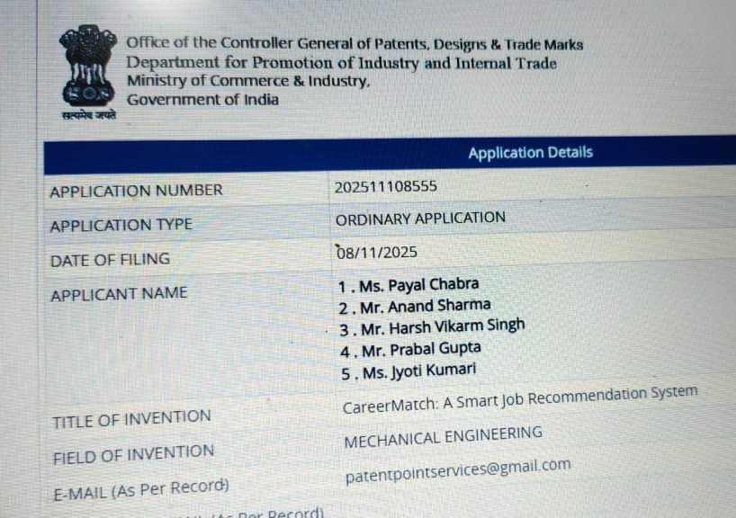

PLAGIARISM REPORT
